World Art Festival e-Voting and Feedback System
Use Case Specifications: Administrator Management of Event Details

Version 1.0

Revision History
Date | Version | Description | Author
10/10/2015 | 1.0 | Use cases defining Voter interaction with the system at the time of using the voterID card, the selection of the block and submission of the vote. | Julio Orozco
11/5/2015 | 1.1 | Added new Use Case “Use voterID Card” | Julio Orozco
11/20/2015 | 2.0 | Changed all instances of ‘session’ to ‘block’ to match the ERD. (Must stick to the same naming convention) | Timothy Folds

Table of Contents
1. Diagram of Voter selection of blocks and submision of vote 5
2. Use voterID Card 5
2.1 Brief Description 5
2.2 Basic Flow of Events 5
2.2.1 Voter gets a voterID card 5
2.2.2 Voter use voterID card to login at the kiosk 5
2.3 Alternative Flows 5
2.3.1 A1 Voter lost his voterID card and wants to login. 5
2.3.2 A2 All voters will be given the option to enter demographic information and remains anonymous 5
2.4 Subflows 5
2.5 Key Scenarios 5
2.5.1 Success scenarios 6
2.5.2 Failure scenarios 6
2.6 Preconditions 6
2.7 Postconditions 6
2.8 Extension Points 6
2.9 Special Requirements 6
2.10 Additional Information 6

3. Voter selects block block 6
3.1 Brief Description 6
3.2 Basic Flow of Events 6
3.2.1 Voter look for blocks 6
3.2.2 Selects blocks where films are 6
3.3 Alternative Flows 6
3.3.1 A1 Voter can't find the block block he wants 6
3.3.2 A2 Voter wants to vote for film that was presented last block yesterday 6
3.4 Subflows 6
3.5 Key Scenarios 6
3.5.1 Success scenarios 6
3.5.2 Failure scenarios 6
3.6 Preconditions 7
3.7 Postconditions 7
3.8 Extension Points 7
3.9 Special Requirements 7
3.10 Additional Information 7

4. Submit Vote
4.1 Brief Description 7
4.2 Basic Flow of Events 7
4.2.1 Voter chooses the desired film or films 7
4.2.2 Voter click on the radio button 7
4.2.3 Voter submits his vote 7
4.2.4 Block greys out 7
4.2.5 Voter can repeat steps 1 to 4 7
4.3 Alternative Flows 7
4.3.1 Voter wants to vote for two films 7
4.3.2 Voter submit vote and block does not grey out 7
4.4 Subflows 7
4.5 Key Scenarios 7
4.5.1 Success scenarios 7
4.5.2 Failure scenarios 8
4.6 Preconditions 8
4.7 Postconditions 8
4.8 Extension Points 8
4.9 Special Requirements 8
4.10 Additional Information 8

Use Case Specifications: Administrator Management of Event DetailsVoter Selection of Blocks and Submitting Vote

Diagram of Voter use cases involving event details
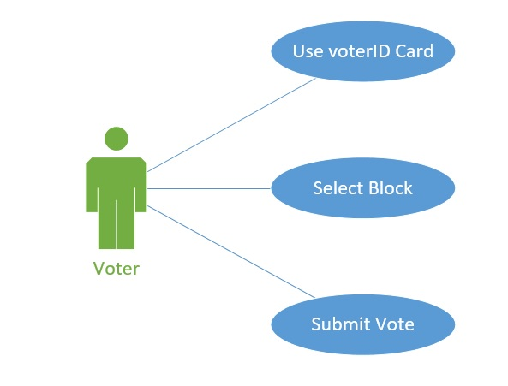

Use voterID Card

Brief Description
Each person that attends to the film festival and wants to vote will be given a voterID card, which they will use throughout the event to vote on a single film per block.

Basic Flow of Events

Voter gets a voterID card.
People who attend to the event and want to vote, they need to get a voterID card. The voterID card would be sold by the entrance.

Voter use voterID card to login at the kiosk
Voters would use the voterID card at the kiosk by scanning the QR code on the card, which generates a unique identifier per voter.

Alternative Flows

A1 Voter lost his voterID card and wants to login

A1. Voter lost his voterID card and wants to vote with no card. Voter could either get a new card or talks with admin in order to allow him to vote with no card

A2 All voters will be given the option to enter demographic information and remains anonymous
A2. Once a voter uses his voterID card at the login page, he would be prompted if he/she wants to enter demographic information about themselves but it would be totally anonymous. It’s optional so voter can either accept it or not and the decision won’t affect voter’s ability to vote.

Subflows
None

Key Scenarios

Success scenarios
Voter is able to get the voterID card and use it at the kiosk to access to the e-voting system. Basic flow

Failure scenarios
Voter won’t be able to vote since he lost his voterID card- Alternative flow A1

Preconditions
Administrator will pre-issue voterID cards and print additional to ensure everyone who wants to vote can obtain a voterID card.

Postconditions
Voter now can select the block where he/she wants to vote.

Extension Points
None

Special Requirements
None

Additional Information
None

Select Block Block

Brief Description
Voter can select the desired block from the block blocks page.

Basic Flow of Events

Voter look for the block that he\she attended or any block he wants.
There would be blocks with 4 films in each, and Voter has to look for the block where the films he wants to vote for is at. He can look for one block or more than one.

Select the desired blocks.
Once the voter finds the blocks that he wants to vote in, he proceed to the next phase.

Alternative Flows

Voter can’t find the block block he wants.

A1. There are few reason voter could not find the block he wants. He might thought that he could look for a block that he attended yesterday or since there are several block he hasn’t gone through the whole block page.

Subflows
None

Key Scenarios

Success scenarios
Voter is able to find the desired section and all the films he watched are in the correct block blocks.-basic flow.

Failure scenarios
Voter won’t be able to vote for a film he watched on the last block yesterday- Alternative flow A1

Preconditions
Admin successfully loads all films’ information in their respective blocks.

Postconditions
Voter has made his mind on how many block he wants to vote in.

Extension Points
None

Special Requirements
None

Additional Information
None

Submit Vote

Brief Description
Voter choose the desired film on one block or few block and submit his vote or votes for the films.

Basic Flow of Events

Voter chooses the desired film.
Voter chooses one film or many films in their respective block blocks.

Voter click on the radio button.
In each block there are four films, each films has a radio button below and voter chooses a film clicking on a radio button.

Voter submits his vote clicking the submit button

Once Voter picks the film he wants to vote for by clicking the radio button below it, he can submit his vote clicking on the submit button.

Block greys out

Once a vote is submitted that block greys out since Voter can only vote for one film per block.

Voter can repeat steps 1 to 4.
Voter is able to repeat steps 1 to 4 in different blocks where Voter would like to vote for specific films.

Alternative Flows

Voter wants to vote for two films.

A1. Voter might attended to a block where two films out of the four he watched, he would like to vote for. He probably would not be able to vote for two films in the same block, unless Admin allows it.

Subflow
None

Key Scenarios

Success scenarios
Voter successfully submits his vote for the desired films in several block with no problem at all.-basic flow

Failure scenarios
Voter want to vote for two films in the same block, but Admin won’t allow to do so. - Alternative flow A1

Preconditions
Voter has made his mind and chose blocks where he wants to vote.

Postconditions
Voter submitted vote and system stores vote in the database and automatically displays it on the leaderboard. Now, admin can pull data and make his reports.

Extension Points
None

Special Requirements
None

Additional Information
None

